**#DECORATOR**

**#A decorator is a callable object which takes function as an argument and returns the modified function without modifying the original function**

**#A decorator which takes another function and returns the strings which actual function is having**

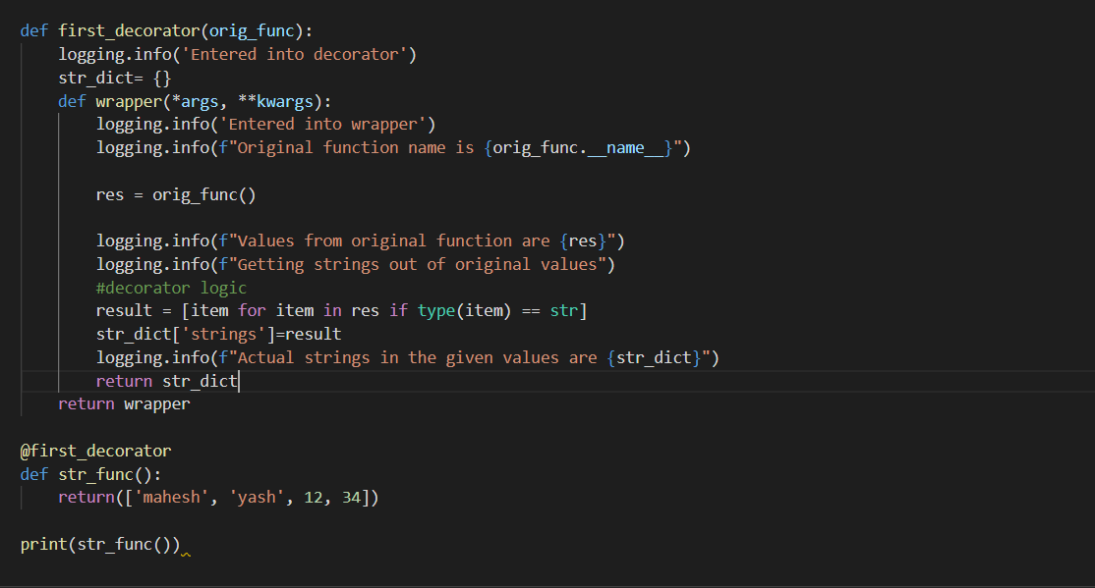

**#log file**

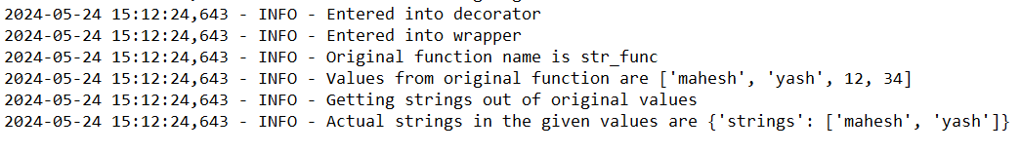

**#Checking the mobile number is valid or not using regex and using decorator**

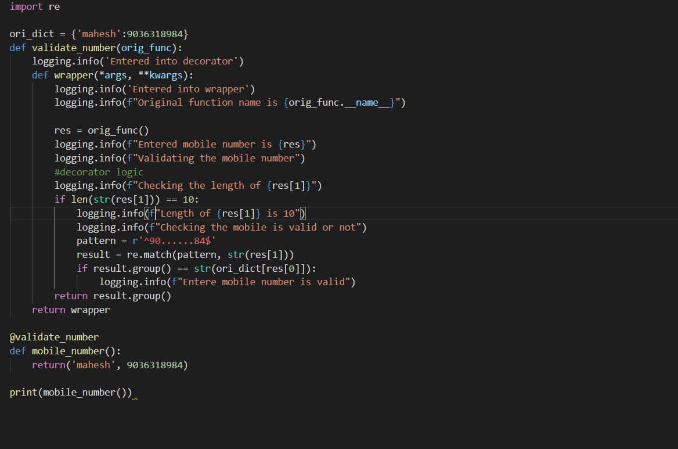

**#log file**

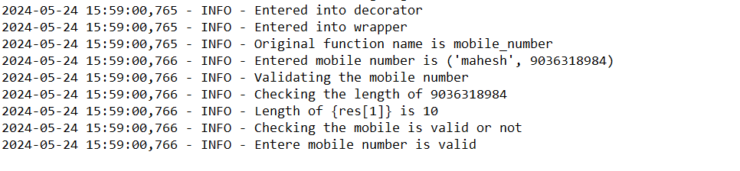

**#checking the email id is valid or not using regex and decorator**

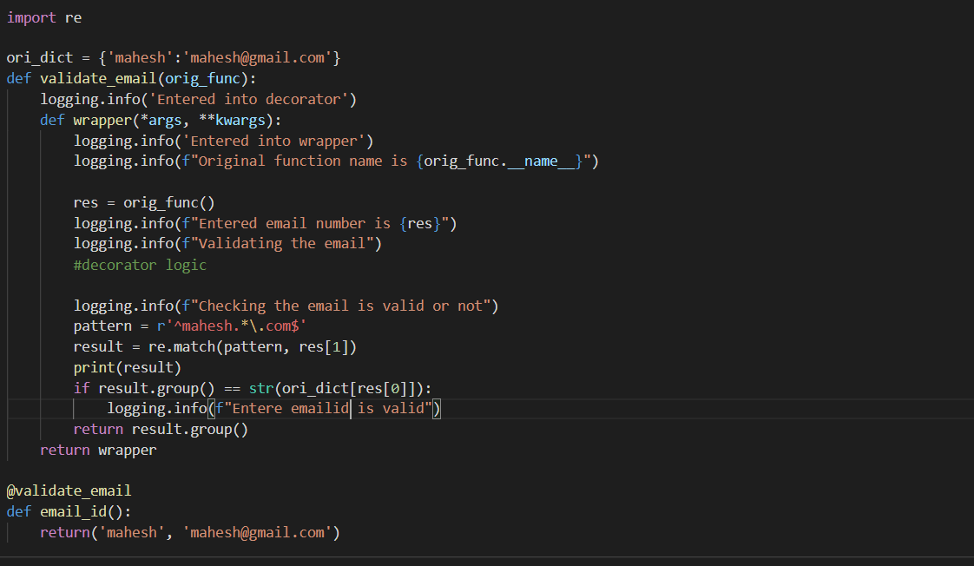

**#log file**

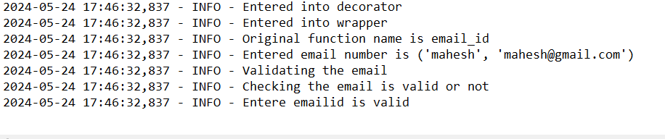

**#Performing addition or substraction based on user requirement using decorator**

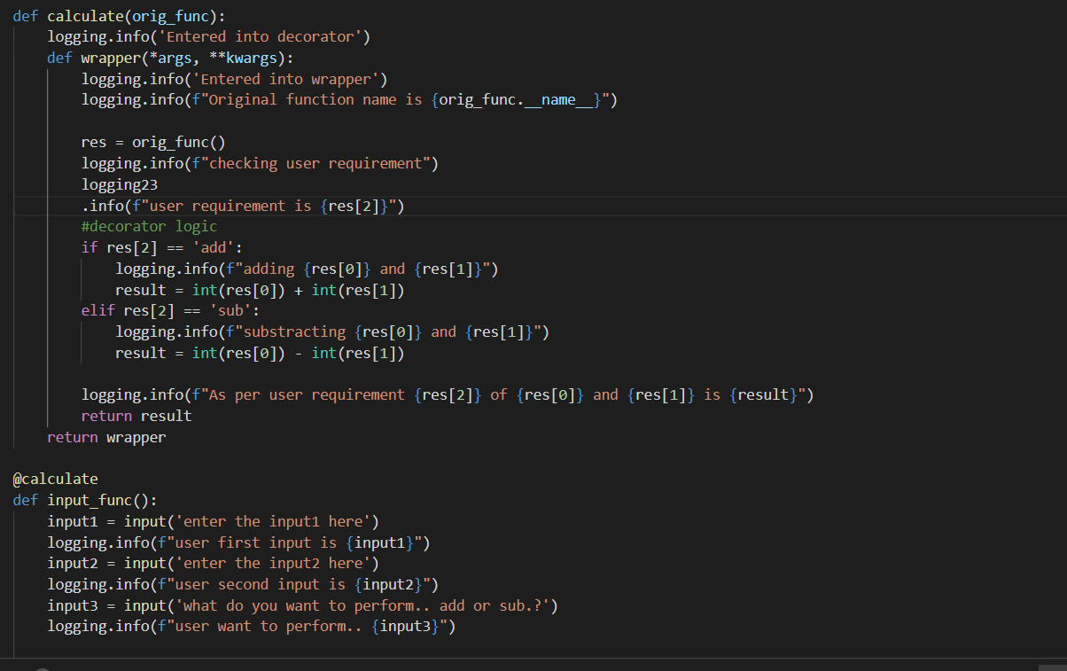

**#log file**

**#performing add**

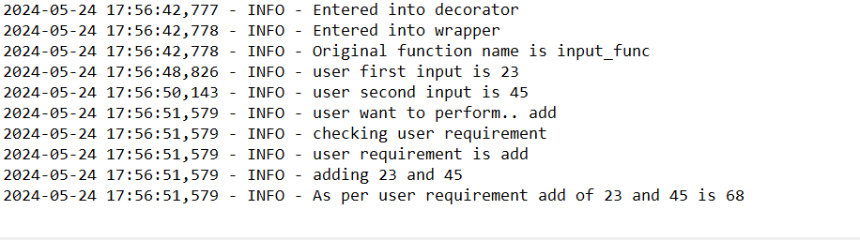

**#performing substraction**

